**Song selector application Usage Documentation**

**Overview**

This documentation provides a simple guide on how to use the Song Selector API. The API allows you to retrieve a list of songs from a specified artist, filtered by a starting letter. You can easily interact with the API using the Swagger UI provided.

**Steps to Use the Application**

1. **Clone the Repository**:
   * Clone the repository to your local machine using the following command:

**git clone <** **https://github.com/DanielOyegadeZuto/Sprint-Song-Selector.git>**

1. **Pull Down Any Changes**:

* Navigate to the cloned directory and pull down any changes:
* Use the command:

**git pull**

1. **Run the Application**:

Start the application by navigating to the project directory and running the following command:

**dotnet run**

1. **Access Swagger UI**:

* Once the application is running, open your web browser and navigate to the Swagger UI. Typically, it will be available at:

[**http://localhost:<port>/swagger**](http://localhost:%3cport%3e/swagger)

* Replace <port> with the port number where your application is running (usually displayed in the console when the app starts).

1. **Using the Get Artist Method**:
   * In the Swagger UI, locate the method named getArtistSongs under the SongSelector controller.
   * This method allows you to retrieve songs from a specific artist, filtered by the starting letter.

**Required Fields**

* **artistId**: The unique ID of the artist. This is a required field.
* **totalLimit**: The maximum number of songs to retrieve from the artist's catalogue. This is a required field.
* **letter**: The starting letter to filter the songs by.

**Example Artist IDs**

To simplify the process, you can use the following example artist IDs:

* **Bloc Party**: 3MM8mtgFzaEJsqbjZBSsHJ
* **Pink Floyd**: 0k17h0D3J5VfsdmQ1iZtE9
* **King Krule**: 4wyNyxs74Ux8UIDopNjIai
* **The Beatles**: 3WrFJ7ztbogyGnTHbHJFl2

**Example Request**

1. **Input Parameters**:
   * **artistId**: 0k17h0D3J5VfsdmQ1iZtE9 (Pink Floyd)
   * **totalLimit**: 300
   * **letter**: A
2. **Steps**:
   * Enter the artistId in the artistId field.
   * Enter 100 in the totalLimit field to retrieve up to 100 songs.
   * Enter A in the letter field to filter songs starting with the letter 'A'.
3. **Submit the Request**:
   * Click the "Execute" button to submit the request.
   * 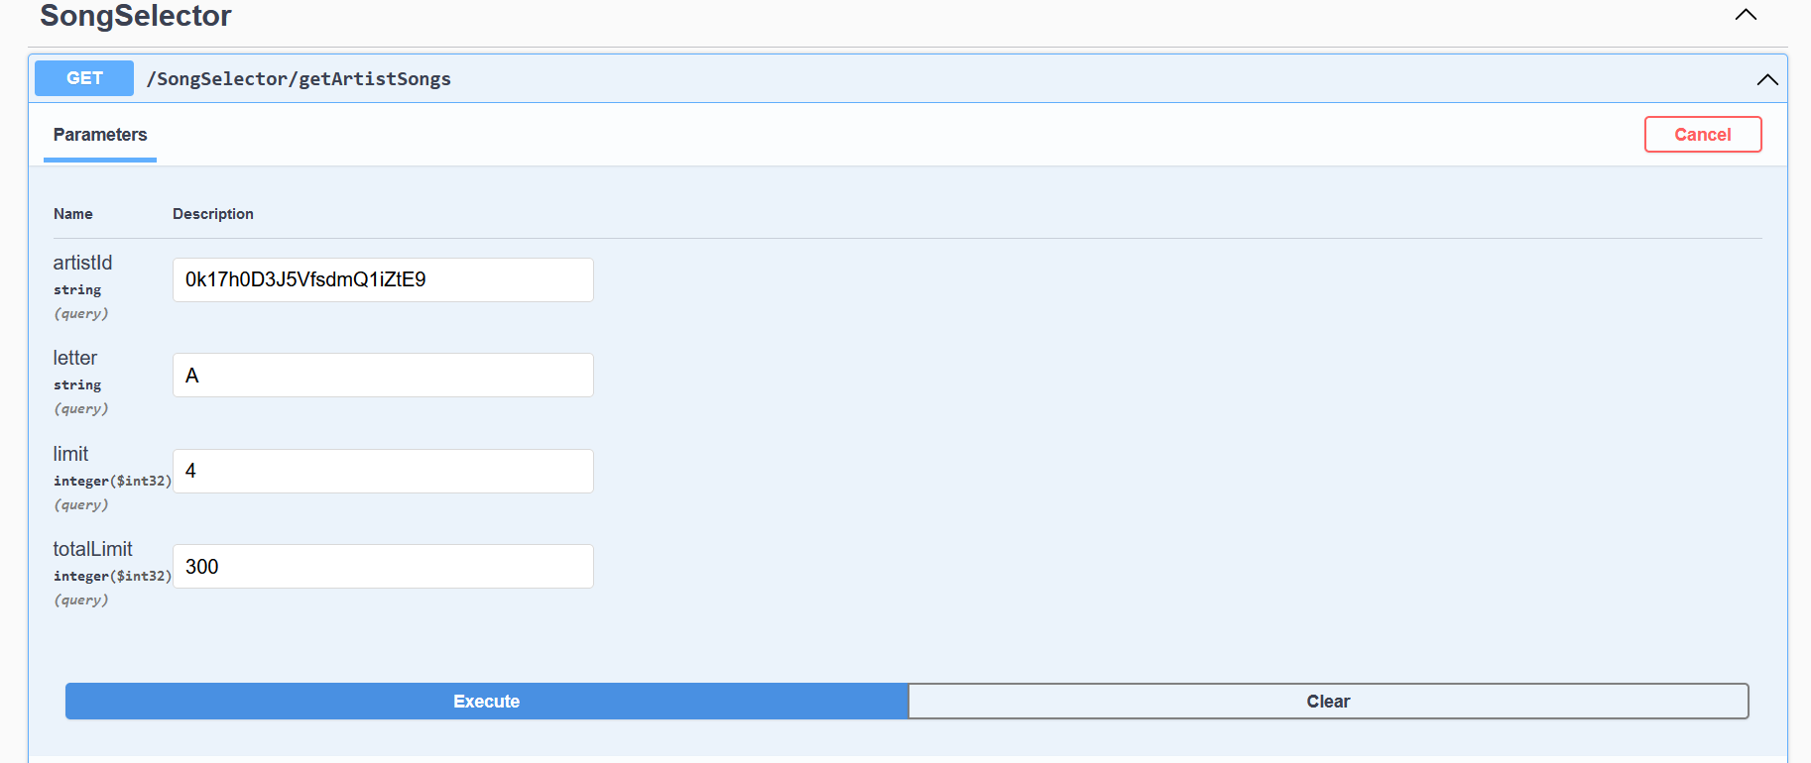The response will display a list of songs from the specified artist, filtered by the provided letter if applicable.

**Output**

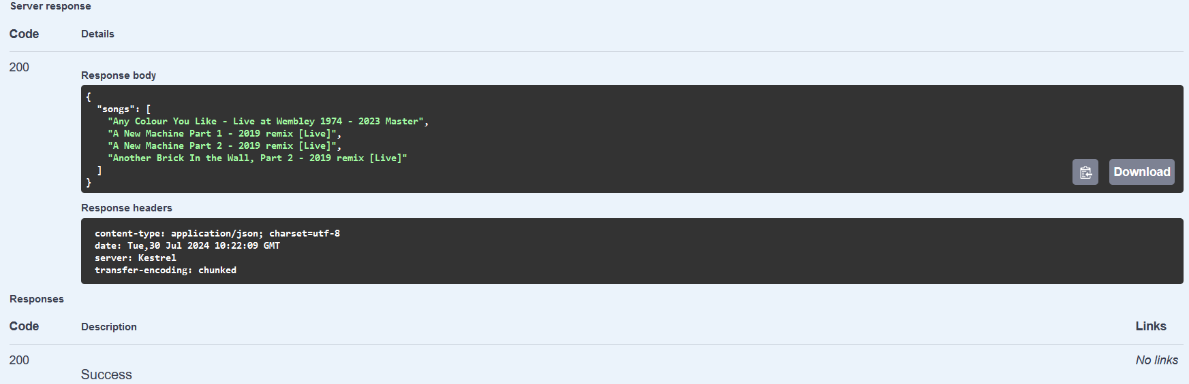The output will be a JSON object containing a list of songs matching the criteria. For example: